**GUI Functionality evidence test**

Successfully loading a log file

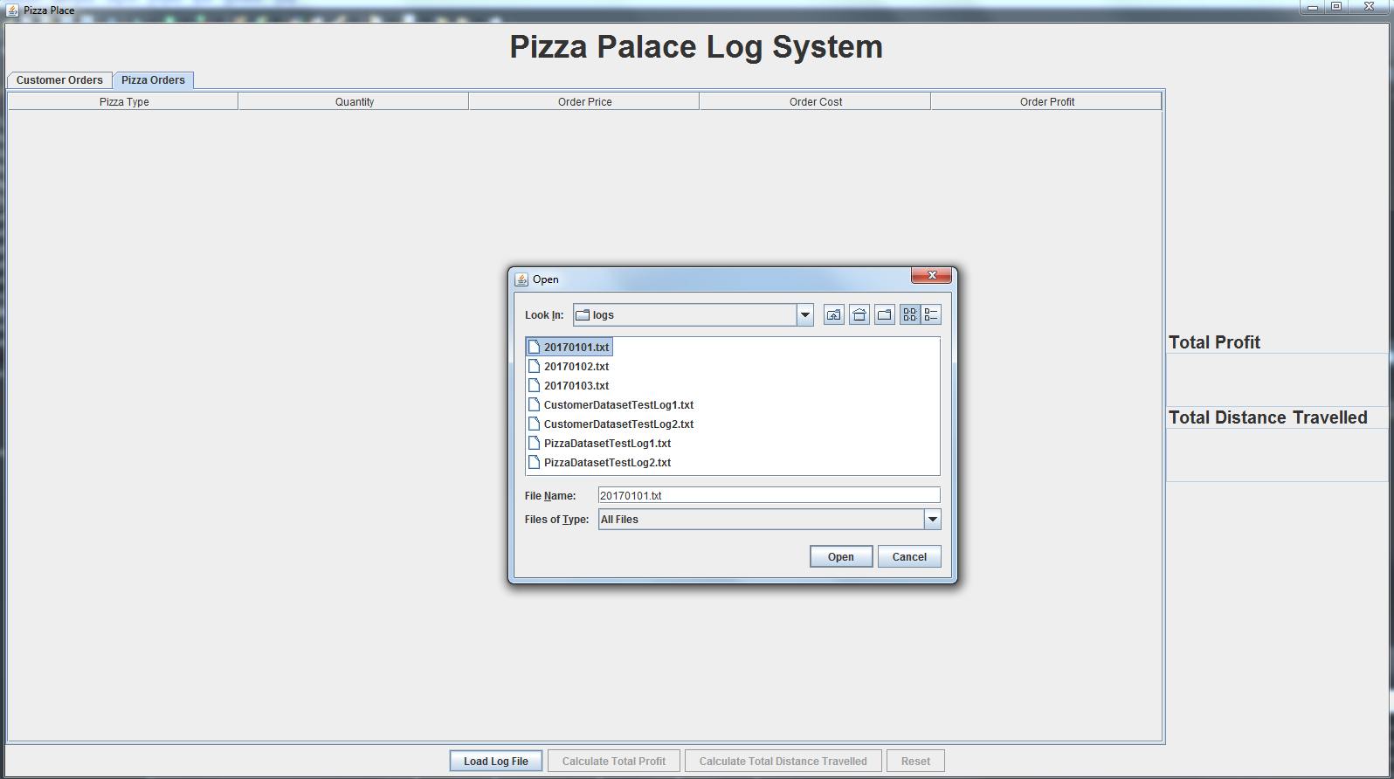

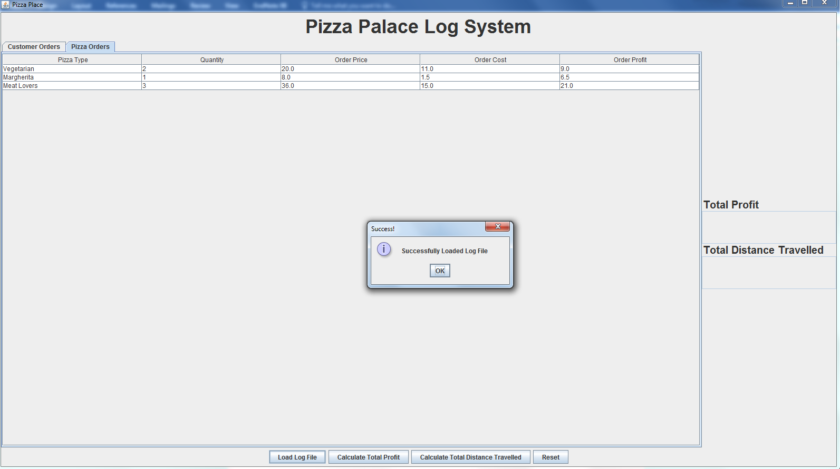

Successfully displaying details related to the order as outlined in Section 5.4.

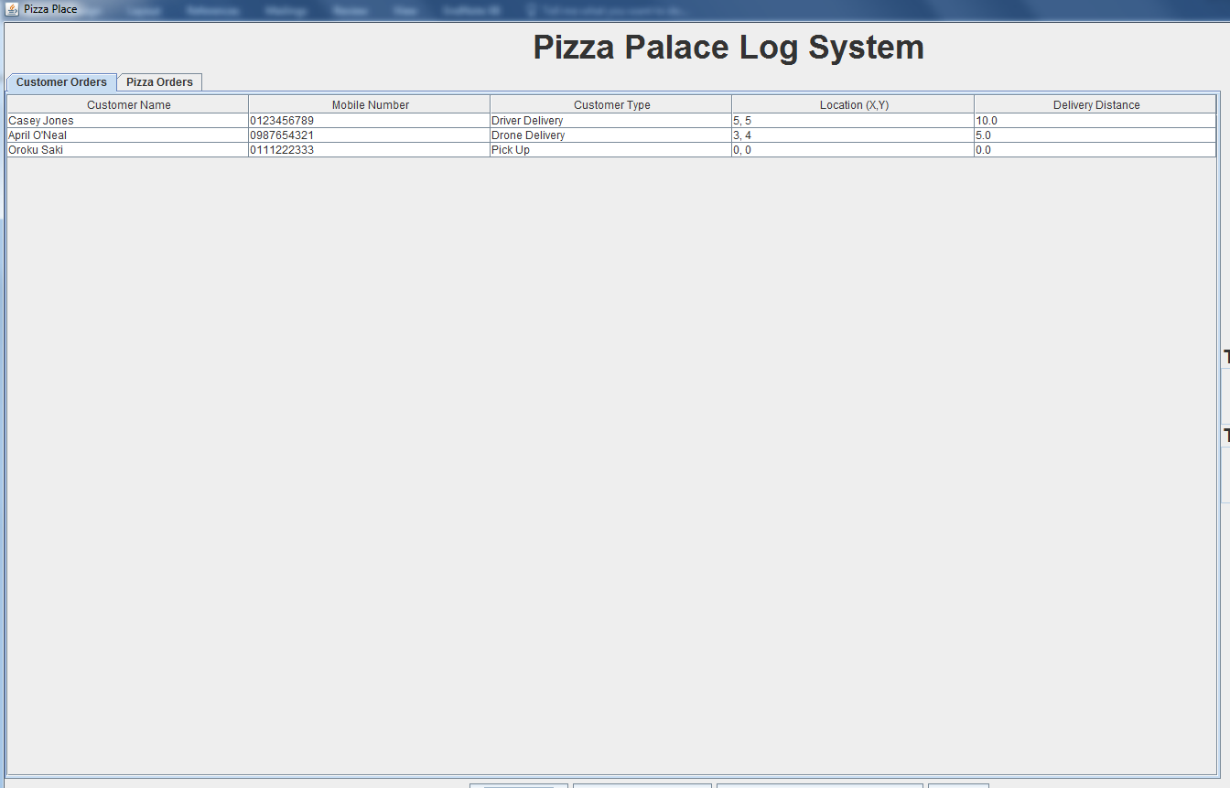

Successfully displaying details related to the order as outlined in Section 5.4.

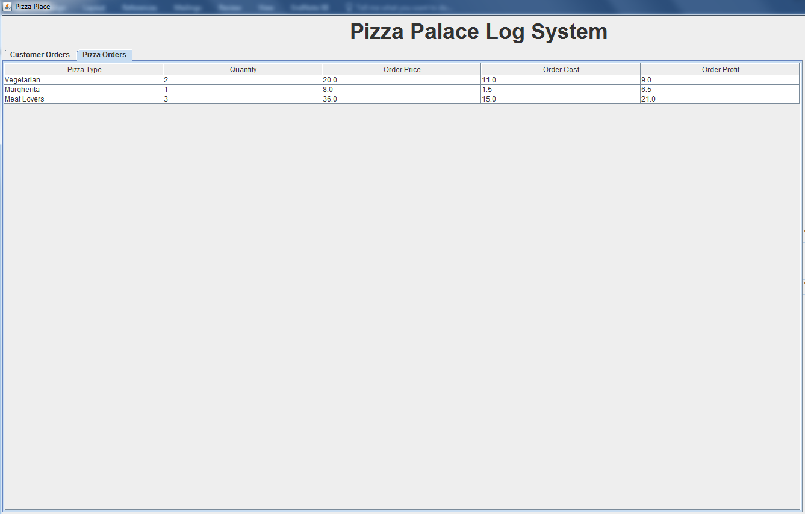

Successfully calculating and displaying the total distance travelled as outlined in Section 5.4.

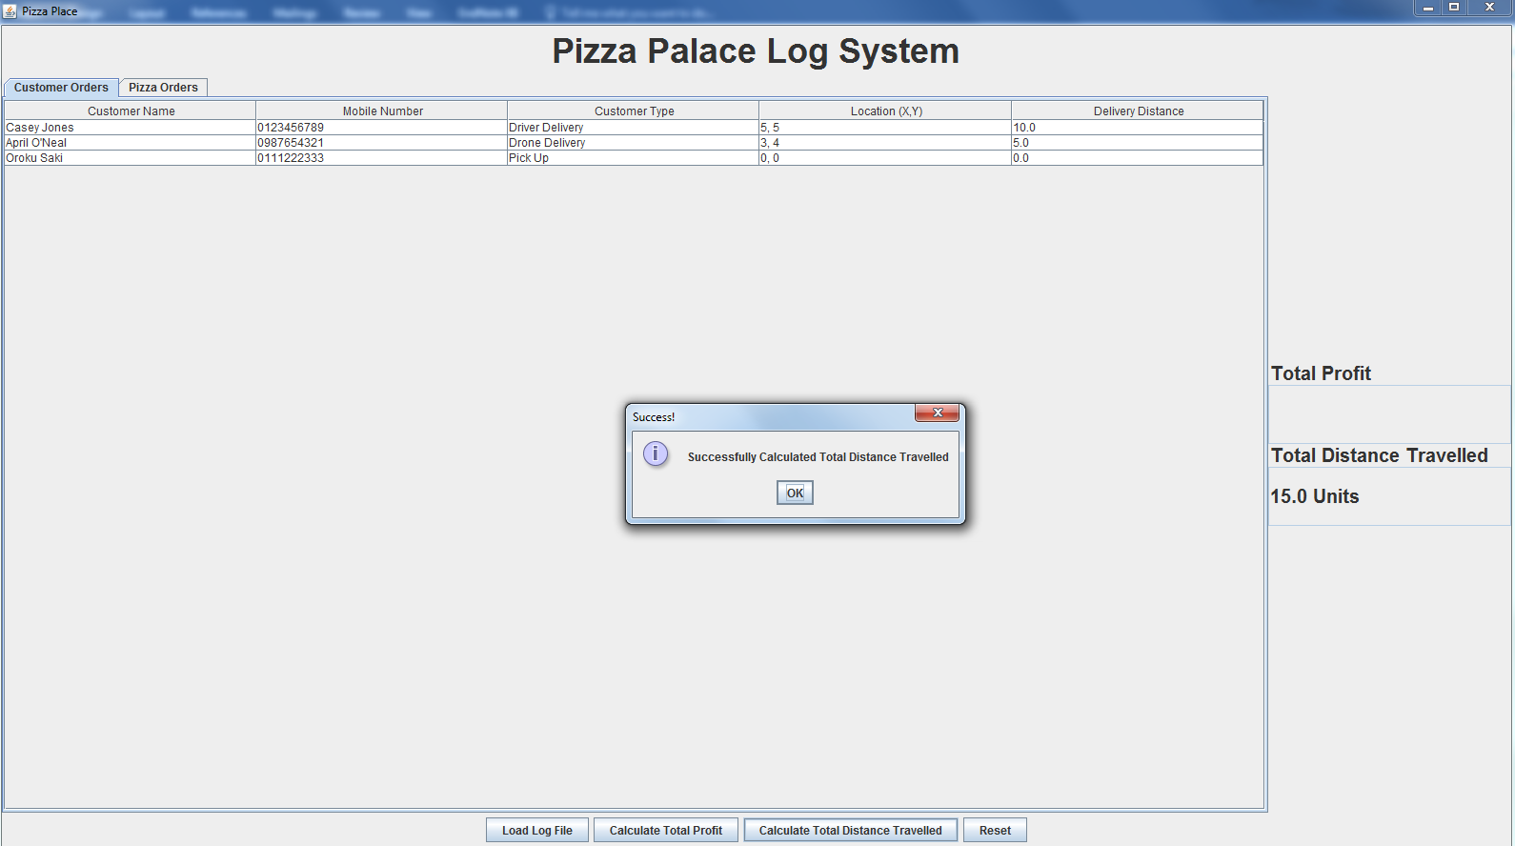

Successfully calculating and displaying the total profit as outlined in Section 5.4.

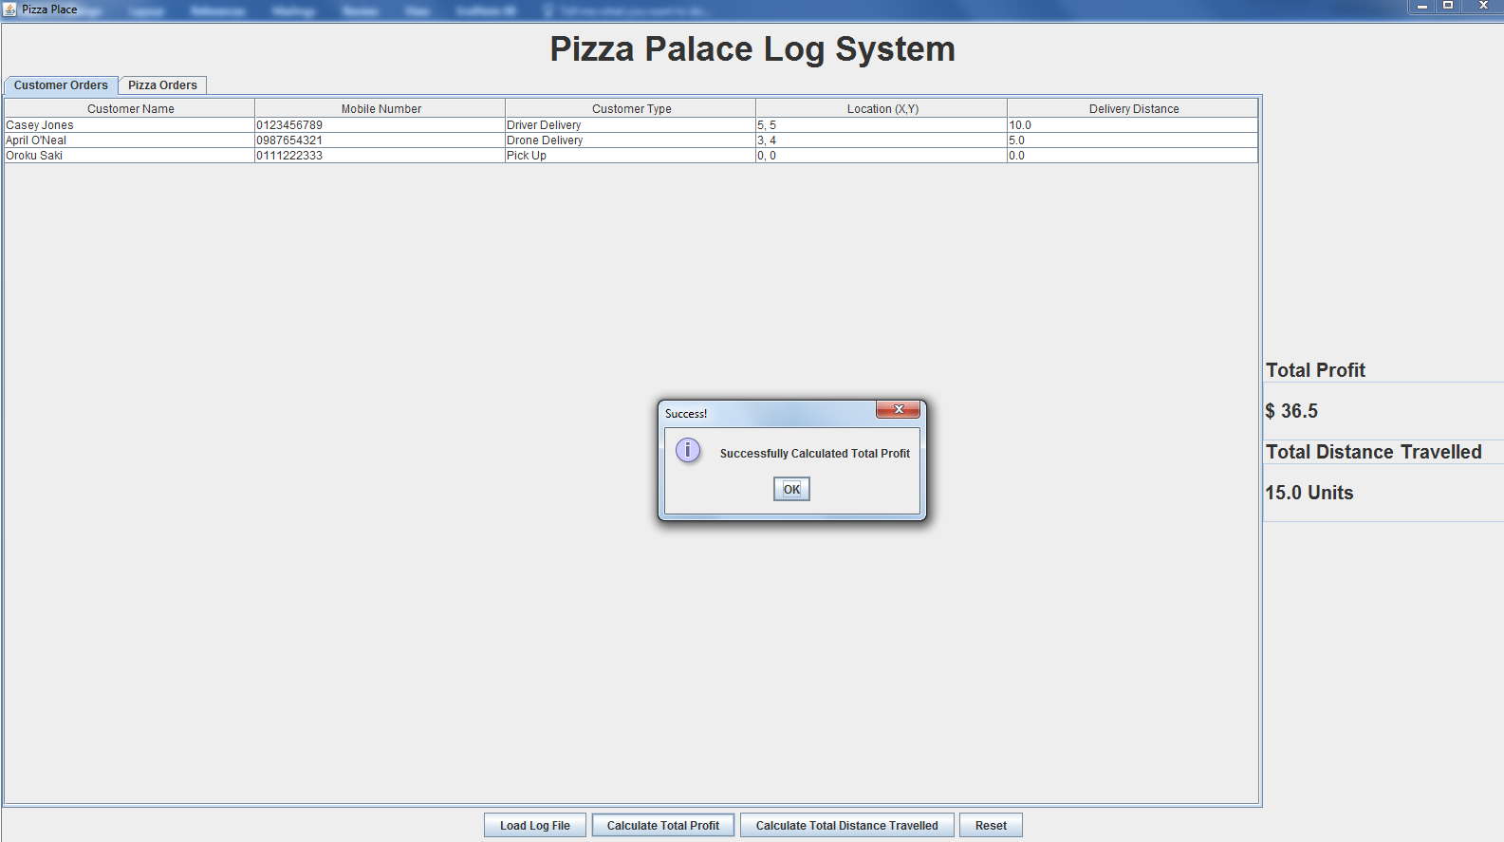

Successfully resetting the system and clearing all information as outlined Section 5.4.